Learning to live and work together

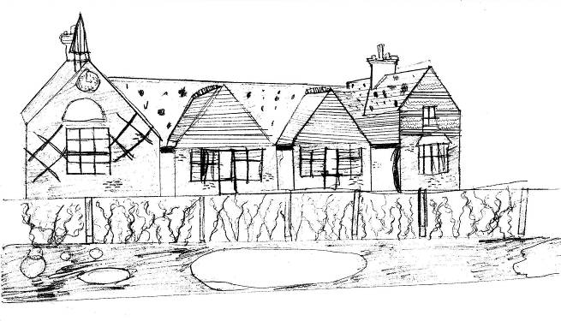
LAUGHTON COMMUNITY PRIMARY SCHOOL

Church Lane
Laughton
LEWES
East Sussex
BN8 6AH

Telephone: 01323 811306
Email: office@laughton.e-sussex.sch.uk
Deputy Headteacher : Katie Blood BA (QTS)
Headteacher : Mrs R M West BEd(Hons) NPQH

27/06/13

Dear Parents,

Pupils in Key Stage 2 will be performing a concert of “Musical Mayhem” on Thursday 4th July. The doors will open at 6.00pm when refreshments will be available to buy. The concert will start at 6.30pm; seats are unreserved.

Tickets will be sold before and after school in the playground on the following dates: Friday 28th June, Monday 1st July and Wednesday 3rd July. Tickets cost £2 each and all audience members will need one.

We request that no under 5’s come to this concert, but school age children are welcome. Pupils in Underwater and Bugs class will have seen the concert earlier in the day and cannot play outside during the concert.

There are a limited number of tickets available for the dress rehearsal earlier in the day, if you cannot make it to the evening concert- if necessary pre-school children could come to this. Please see Mrs Miller in the office regarding tickets for this.

Best wishes

Katie Blood Emily Geering.

