Week 1 – Find and research a local river. Research one animal or eco-system that is linked to rivers. If possible, do a walk along a river and photograph your journey.
Remember to complete your Mathletics and grammar sheet and read for at least 20 minutes daily.
Reminders:
- PE days are Monday and Thursday
- Children need a named water bottle in school
- Children may need a hat in school on days that are sunny.

Week 2 – Using any media you choose (pencil, computer etc) create a detailed map of the area you live (or Laughton village if you would prefer). Make sure you include a key.
Remember to complete your Mathletics and grammar sheet and read for at least 20 minutes daily.
Reminders:
- PE days are Monday and Thursday
- Children need a named water bottle in school
- Children may need a hat in school on days that are sunny.

Week 3 – The ‘What If’ challenge:
What if we did not have maps?
In your answer, go deeper – do not just say one sentence statements. I challenge you to use words like ‘because’, ‘so’ ‘as a result’ and ‘due to’.
Remember to complete your Mathletics and grammar sheet and read for at least 20 minutes daily.
Reminders:
- PE days are Monday and Thursday
- Children need a named water bottle in school
- Children may need a hat in school on days that are sunny.

Week 4 – These words are all found in The Wind in the Willows. Create a small dictionary to define what they mean. Add any others you would like to from the book.
- chaff
- thither
- meander
- stoop
- gingerly
- sheer
- luncheon
- bedraggle
- quiver
- conceited
Remember to complete your Mathletics and grammar sheet and read for at least 20 minutes daily.
Reminders:
- PE days are Monday and Thursday
- Children need a named water bottle in school
- Children may need a hat in school on days that are sunny.
Week 5 – Design a map of a fictional setting in the style of the one from the Wind in the Willows.
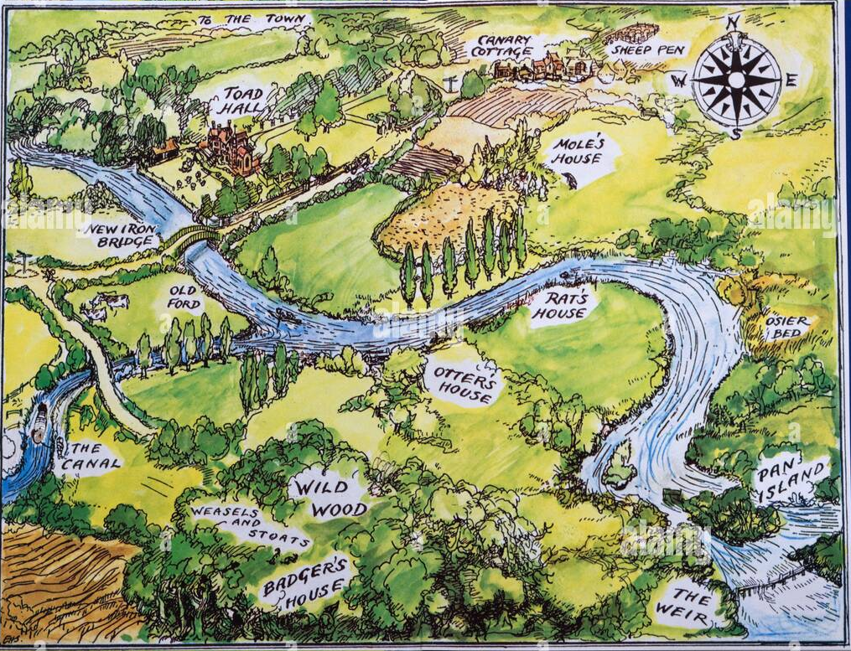
Remember to complete your Mathletics and grammar sheet and read for at least 20 minutes daily.
Reminders:
- PE days are Monday and Thursday
- Children need a named water bottle in school
- Children may need a hat in school on days that are sunny.

Week 6 – Bubble and squeak is famously in the Wind in the Willows. Research the history behind it’s name and have a go at making your own recipe.
Remember to complete your Mathletics and grammar sheet and read for at least 20 minutes daily.
Reminders:
- PE days are Monday and Thursday
- Children need a named water bottle in school
- Children may need a hat in school on days that are sunny

